Work - 02
CLASS 09 - SCIENCE

 | Section A
1 | Match the following Column A with Column B:  | [2]
2 | Match the following Column A with Column B: 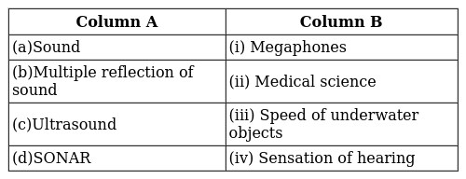 | [2]
3 | Match the following Column A with Column B: 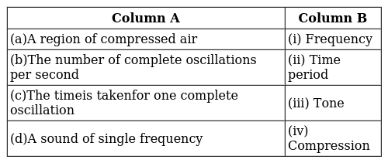 | [2]
4 | Match the following Column A with Column B: 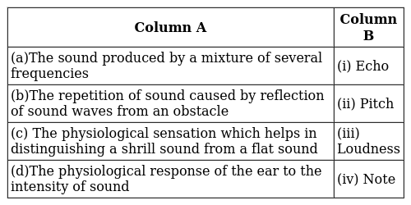 | [2]
5 | Match the following Column A with Column B: 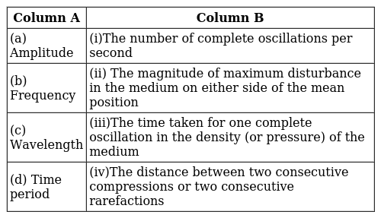 | [2]
6 | Match the following Column A with Column B: 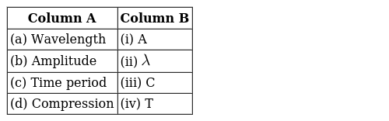 | [2]
7 | Match the following Column A with Column B: 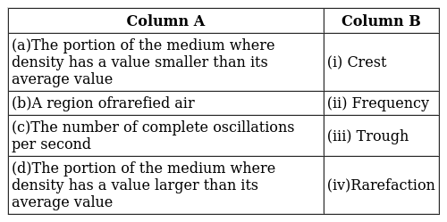 | [2]
8 | Match the following Column A with Column B: 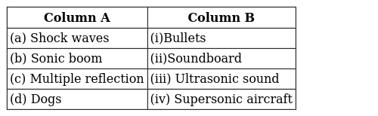 | [2]
9 | Match the following Column A with Column B:  | [2]
 | Section B
10 | A human heart on an average is found to beat 75 times a minute. Calculate its frequency. | [2]
11 | Sound requires a medium to travel? Justify experimentally. | [2]
12 | How are the wavelength and frequency of a sound wave related to its speed? | [2]
13 | A sound wave of wavelength 0.332 m has a time period of 10$​^{−3}$ s. If the time period is decreased to 10 $​^{−4}$ s, calculate the wavelength and frequency of new wave. | [2]
14 | A Sonar emits pulses on the surface of water which are detected after reflection from the bottom. If the time interval between the emission and detection of the pulse is 2 s find the depth of water. Take velocity of sound in water as 1531 ms$​^{−1}$ . | [2]
15 | A person has a hearing range from 20 Hz to 20 kHz. What are the typical wavelengths of sound waves in air corresponding to these two frequencies? Take the speed of sound in air as 344 ms$​^{−1}$ . | [2]
16 | How does the sound produced by a vibrating object in a medium reach your ear? | [2]
17 | What do you understand by loud and soft sound? | [2]
18 | Why is the ceiling and wall behind the stage of good conference halls or concert halls made curved? | [2]
19 | What are wavelength, frequency, time period and amplitude of a sound wave? | [2]
20 | A Child hears an echo from a cliff 4 seconds after the sound from a powerful cracker is produced. How far away is the cliff from the child? (Take velocity of sound in air as 340 ms$​^{−1}$ ) | [2]
21 | A stone is dropped from the top of a tower 500 m high into a pond of water at the base of the tower. When is the splash heard at the top? Given, g = 10 ms$​^{−2}$ and speed of sound = 340 ms $​^{−1}$ . | [2]
22 | When a sound is reflected from a distant object, an echo is produced. Let the distance between the reflecting surface and the source of sound production remains the same. Do you hear echo sound on a hotter day? | [2]
23 | When vertically jerk is given to a string, transerve waves are formed. Give three features of these waves. | [2]
24 | A sonar device on a submarine sends out a signal and receives an echo 5 s later. Calculate the speed of sound in water if the distance of the object from the submarine is 3625 m. | [2]
25 | A boy hears the echo of his own voice from a distant hill after 0.8 second. If the speed of sound in air is 340 m/s, calculate the distance of hill from the boy. | [2]
26 | Suppose you and your friend are on the moon. Will you be able to hear any sound produced by your friend? | [2]
27 | Give two practical applications of reflection of sound waves. | [2]
28 | For hearing the loudest ticking sound heard by the ear, find the angle x in the Fig. 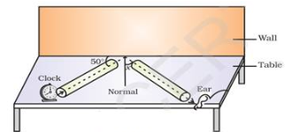 | [2]
29 | A wave is moving in the air with a velocity of 340 m/s. Calculate the wavelength if its frequency is 512 Hz. | [2]
30 | A girl is sitting in the middle of a park of dimension 12 m$×$ 12 m. On the left side of it there is a building adjoining the park and on the right side of the park, there is a road adjoining the park. A sound is produced on the road by a cracker. Is it possible for the girl to hear the echo of this sound? Explain your answer. | [2]
31 | Describe with the help of a diagram, how compressions and rarefactions are produced in air near a source of sound. | [2]
32 | Explain how bats use ultrasound to catch their prey. | [2]
33 | A stone is dropped in a well 44.1 m deep. The sound of splash is heard, 3.13 s after the stone is dropped. Find the velocity of the sound in air. (Take g = 9.8 ms$​^{−2}$ ) | [2]
34 | Why are sound waves calledmechanical waves? | [2]
35 | What is loudness of sound? What factors does it depend on? | [2]
36 | What is a soundboard? Explain the working of a soundboard with the help of a labelled diagram. | [2]
37 | Why are the ceilings of concert halls curved? | [2]
38 | Does sound follow the same laws of reflection as light does? Explain. | [2]
39 | Why do we see light first and hear the sound later during thunderstorm? | [2]
40 | Cite an experiment to show that sound needs a material medium for its propagation. | [2]
41 | Prove that$V=υλ$ , where the symbols have their usual meanings. | [2]
42 | Which wave property determines  - loudness,  - pitch? | [2]
43 | Two children are at the opposite ends of a long iron pipe. One of them strikes the end of iron pipe with a stone. Find the ratio of time taken by the sound waves in air and in iron to reach the other child. (Speed of sound in air = 340 ms$​^{−1}$ and speed of sound in iron is 5130 ms $​^{−1}$ ). | [2]
44 | Explain how sound is produced by your school bell. | [2]
45 | Explain how bats use ultrasound to catch a prey. | [2]
46 | Flash and thunder are produced simultaneously. But thunder is heard a few seconds after the flash is seen. why? | [2]
47 | Establish the relationship between the speed of sound, its wavelength, and frequency. If the velocity of sound in air is 340 ms$​^{−1}$ . Calculate  - wavelength when the frequency is 256 Hz.  - frequency when the wavelength is 0.85 m. | [2]
48 | Sound is produced due to a vibratory motion, then why a vibrating pendulum does not produce sound? | [2]
49 | A person has hearing range of 20 Hz to 20 kHz. Calculate the wave lengths of sound waves in air corresponding to above frequencies? Take speed of sound in air as 340 ms$​^{−1}$ . | [2]
50 | When a sound is reflected from a distant object, an echo is produced. Let the distance between the reflecting surface and the source of sound production remain the same. Do you hear echo sound on a hotter day? | [2]
51 | A ship sends out an ultrasound that returns from the seabed and is detected after 3.42 s. If the speed of ultrasound through seawater is 1531 m/s, what is the distance of the seabed from the ship? | [2]
52 | A longitudinal wave of wavelength 1 cm travels in air with a speed of 330 m/s. Calculate the frequency of the wave. Can this wave be heard by a normal human? | [2]
53 | A sound wave has a frequency 2 kHz and wavelength 40 cm. How long will it take to travel 1.6 km? | [2]
54 | A sound wave has a frequency of 2 kHz and wave length 35 cm. How long will it take to travel 1.5 km? | [2]
55 | A person is listening to a tone of 500 Hz sitting at a distance of 450 m from the source of the sound. What is the time interval between successive compressions from the source? | [2]
56 | The given graph shows the displacement versus time travelling with velocity of 1500 ms$​^{−1}$ . Calculate the wavelength of the disturbance. 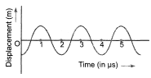 | [2]
57 | A submarine emits a sonar pulse, which returns from an underwater cliff in 1.02 s. If the speed of sound in salt water is 1531 m/s, how far away is the cliff? | [2]
58 | A sound wave travels at a speed of 339 ms$​^{−1}$ . If its wavelength is 1.5 cm, what is the frequency of the wave? Will it be audible? | [2]
59 | The frequency of a source of sound is 100 Hz. How many times does it vibrate in a minute? | [2]
60 | Write full form of acronym SONAR. Explain how the method of echo - ranging is used to determine the depth of sea. | [2]
61 | What is an echo? Name two areas of its application? | [2]
62 | Why do we hear the sound produced by the humming bees while the sound of vibrations of pendulum is not heard? | [2]
63 | Define : - a) Time Period b) Amplitude of a wave | [2]
64 | What is reverberation? How can it be reduced? | [2]
65 | A longitudinal wave is produced on a toy slinky, such that frequency of wave is 20 Hz and the speed of the wave is 30 cms$​^{−1}$ , What is the minimum separation between the consecutive compressions on the slinky? | [2]
66 | How is ultrasound used for cleaning? | [2]
67 | Distinguish between loudness and intensity of sound. | [2]
68 | A boat at anchor is rocked by waves, whose consecutive crests are 100 m apart. If the wave velocity of moving crests is 20 ms$​^{−1}$ , calculate the frequency at which the boat will rock? | [2]
69 | Two children are at opposite ends of an aluminium rod. One strikes the end of the rod with a stone. Find the ratio of times taken by the sound wave in air and in aluminium to reach the second child. Given velocity of sound in air and aluminium are 346 ms$​^{−1}$ and 6420 ms $​^{−1}$ respectively. | [2]
70 | Explain how defects in a metal block can be detected using ultrasound. | [2]
71 | Bats have no eyes still they can ascertain distances, directions nature and size of the objects. Explain why? | [2]
72 | The wavelength of waves produced on the surface of water is 20 cm. If the wave velocity is 24 ms$​^{−1}$ , calculate (a) the number of waves produced in one second (b) the time required to produce one wave. | [2]

